**WF TABS:**

**DETAILS PROD** – EVERYTHING IN WF AT A PRODUCT LEVEL (EXCLUDES NEW COLORS)

**NOS COMBINED** – OH ONLY AND @ UPC/SKN LEVEL

**INACTIVE** – NEW COLORS OH

**DATA ON RAW FILES MOSTLY PULLS FROM PIM**

* DATA PULLED FROM **BM**:
  + S7 IMAGE
  + PRICE

**HOW TO RUN BAY WORKFLOW:**

**Workflow Templates:**

***Macro (Raw Data):*** I:\Merch Ops\Site Operations & Improvements\Saks Direct Site Operations\Work Flow\Master Templates\BAY\ BAY_Daily_Workflow_Looker_Template_v5_PIM

***For Teams:*** I:\Merch Ops\Site Operations & Improvements\Saks Direct Site Operations\Work Flow\Master Templates\BAY\MM.DD.YY_Daily Workflow Report_BAY.xlsx

**Looker:**

1. Go to [Looker link](https://looker.gilt.com/spaces/606)
2. Go to Browse → Shared → BAY 🡪 Digital Operations Reporting:
3. Select:
   1. Bay Inactive UPC (moved from Bay)
   2. PIM_Bay NOS combined
   3. PIM_Bay Workflow and Not On Site
4. Click on “Explore from Here” (CAN OPEN ALL THREE INTO DIFFERENT TABS)
5. This will cause the report to run automatically, CLICK STOP (DOESN’T NEED TO COMPLETELY LOAD)
6. Gear gadget on the upper right hand side, and click download.
   1. *\*Make sure options are updated when downloading, should match image on page below\**
   2. *RENAME THE FILE, UNDER FILENAME*
7. 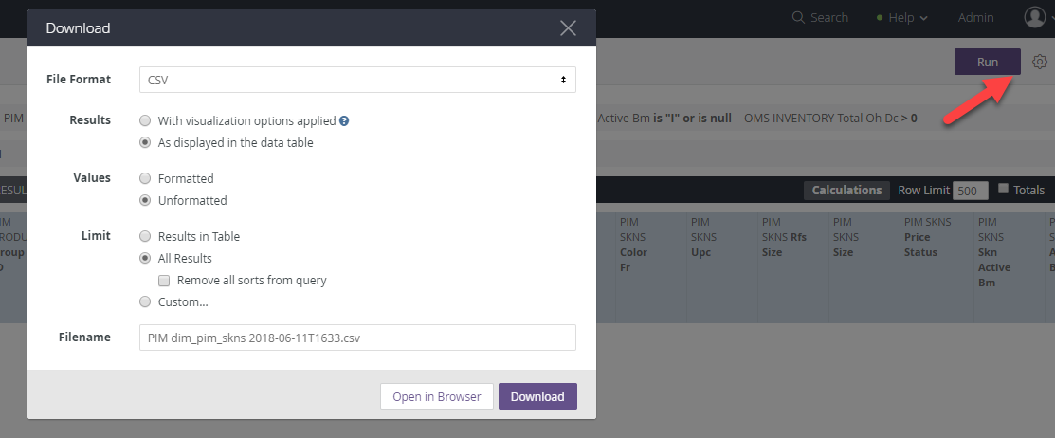

**Inventory Dollar Information:**

**Source:** Microstrategy → BIT

Total warehouse dollars pulls from Microstrategy.

1. Go to [Microstrategy link](http://10.1.130.61/MicroStrategy/asp/Main.aspx?&r_d1446=CE84740F1617791AF0E6865119EA0B14)
2. Click on BIT
3. Under Shared Reports → Divisions Reports
4. Scroll and select “Lord and Taylor” folder → DSG Site Ops
5. Select MIS-IB004A.. - LT-Ecomm by Colour Count
6. Update section 4. Filter on Organization Hierarchy expand on “Organization - The Bay” icon → expand Store/DC icon → select “1963:BAY.COM”

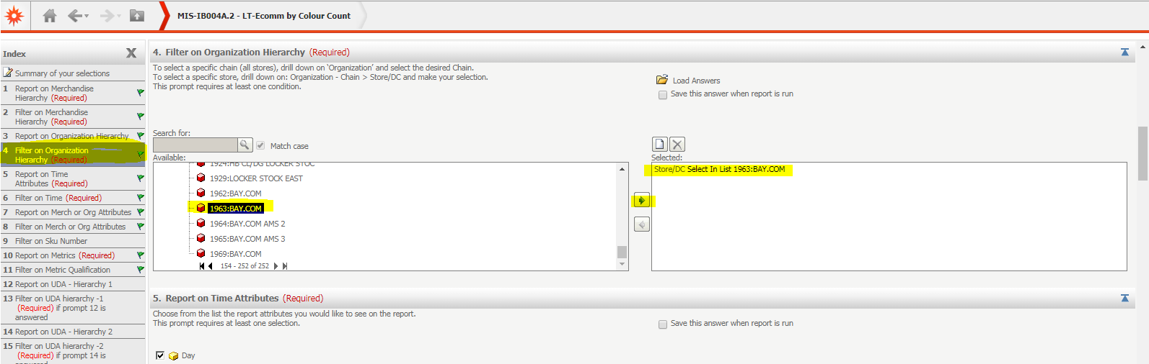

1. Click Run Report → Export report
2. OPEN TEMPLATE
   1. ***Macro (Raw Data):*** I:\Merch Ops\Site Operations & Improvements\Saks Direct Site Operations\Work Flow\Master Templates\BAY
   2. **File**: BAY_Daily_Workflow_Looker_Template_v5_PIM
3. Once file has opened, go to the “ttl_inv” tab
4. Do a vlookup in the TTL inv tab from the BIT Report export to get the Ttl Colours, Ttl $, and Count (Super Vendor Style) per DMM. Starting in the Ttl_inv tab cell **D3** to **F3**.



1. Drag formulas down and calculate
   1. PASTE AS VALUES
2. Do a CTRL+F to replace “#N/A” to 0
3. For the totals (cell D2 to F2) do a sum of each column
   1. *We are removing certain DMM’s because the DC isn’t accurately counting them (even though there is on the BIT report) this makes the total $ more accurate ****nothing is referencing these cells on WF template*
      1. *For example: DMM 48 has $ on the BIT report, but we don’t have that DMM on the ttl_inv tab.*
      2. *The GMMs that are included in this are: 35, 36, 41, 50, 54, 90*
      3. *The DMMs corresponding are: 35, 48, 50, 53, 54, 61, 62, 64, 90*
         1. *Further details reference DOIR-2836*
      4. *On the details products tab we left the $ value in for the products so the teams can still work on these and are not skewing our total NOS.*
4. When calculation is complete, copy & paste as values

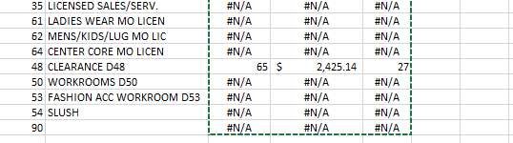

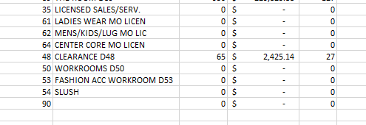

**This information feeds the WF Summary Chart column Q “TTL WH OH”

* AS AN FYI VIEW EMAIL SUBJECT: SLC Trailer & Fulfillment Backlog Update TO SEE HOW MANY TRAILERS COMPLETED THE DAY BEFORE WHICH WILL REFLECT:
  + THE $ VALUE IN THE DC
  + IN THE AMOUNT OF PRODUCTS RECEIVED AT THE DC, WHICH WILL SHOW WITH TODAY’S NOS DATE

**Product Workflow and Not on Site Report:**

**Source:** PIM, OMS, WCS

**Criteria:** BAY,In Workflow and/or Not on Site=T

* Open template ***Macro (Raw Data)***

I:\Merch Ops\Site Operations & Improvements\Saks Direct Site Operations\Work Flow\Master Templates\BAY TEMPLATE

* **FILE NAME**: BAY_Daily Workflow_Template_2019_v9
* OPEN THE PIM BAY_WORFKLOW DOC FROM LOOKER
* CHECK:
  + FINAL COPY TASK COMPLETE
    - SHOULD HAVE THE PREVIOUS BUSINESS DAY’S DATE (AQ)
  + NOS DATE (CA)
    - SHOULD ALWAYS HAVE TODAY’S DATE
* Select all from the Workflow Looker file and copy & paste this selection **with headers** on the Bay Workflow Template Tab “**Looker_Data**”
* On the **Details Products** tab click: **Clear Content, Paste, Paste Special**
* Scroll to “Re-Work Status” Column (BI) and filter on “Re-Work: Complete Fur Attributes”
  + If any of these have a current workflow status of “Exception”, de-select as you will be overriding the Current Workflow Status of these products.
  + Update current_workflow_status from “Awaiting Final Copy” to “Awaiting Complete Copy Attributes”.
  + Update Current Team from “Copy” to “Sample Management”
  + Unfilter
* FILTER ON DMM 27
  + UPDATE GMM TO 5
    - ***PENDING KANHU HIERARCHY UPDATE
  + UNFILTER
* Hit **Refresh Pivots Button** → Workflow charts should now populate with Product $$ Information

**BAY NOS Combined Report:**

**Source:** PIM, OMS

**Criteria:** BAY, OMS Inventory >0

1. THEN COPY AND PASTE TO NOS COMBINED **\*do not include headers\***
2. Copy the formulas above Columns **CA (Inactive UPC)-CE (Duplicate)** paste on Row 3, copy and paste, drag to bottom.
   1. Paste as values.
3. FILTER ON GROUP ID (G) 27
   1. UPDATE DIVISION ID (E) TO 5

**BAY Inactive UPC Report:**

**Source:** PIM, OMS

**Criteria:** BAY, Product-level Active & RFP: True, UPC inactive

1. COPY AND PASTE ONTO UPC_LOOKER TAB NORMALLY WITH HEADERS
2. FILTER ON GROUP ID (B) 27
   1. CHANGE THE DIV ID (A) TO 5
   2. UNFILTER
3. On the Inactive UPC tab, click on Clear Content, Paste, Paste Special
4. SAVE AS NORMAL EXCEL DOC, SAVE IN THIS LOCATION

I:\Merch Ops\Site Operations & Improvements\Saks Direct Site Operations\Work Flow\BAY WIP Daily

1. GO TO THE WF SUMMARY CHART TAB AND UPDATE THE EMAIL WITH THE SUMMARY CHART INFORMATION – TOTAL NOS $, % AND DIFFERENCE
   1. IF IT’S THE START OF A NEW MONTH UPDATE THE LY MONTH AVG % (3.0 IN THE EX BELOW):

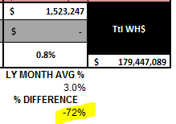

* 1. ADD THE % DIFFERENCE TO THE EMAIL:



1. UPDATE PRODUCTS AND ADDITIONAL COLOR/SIZES

The workflow summary chart should now populate entirely

*Pivots tab is feeding the majority of the workflow summary chart on the product level information.

*Inactive UPC tab is feeding the workflow summary chart only for the NOS information and percentages.

*The workflow summary NOS Breakdown is being driven off the totals from the workflow summary chart.

*** SUMMARY CHART, ADDITIONAL COLOR SIZES PULLS FROM THE NOS COMBINED – TEAMS WHICH PULLS FROM THE INACTIVE UPC TEAM (IF THIS PART OF THE CHART COMES IN BLANK, CHECK THOSE)

**For Teams Report:**

1. COPY THE BELOW FILE (SAVED IN THE SAME PLACE AS THE TEMPLATE)
   1. MM.DD.YY_Daily Workflow Report_BAY
2. PASTE FILE, RENAME AS TODAY’S DATE

\\t49-vol4\ecommerce\Merch Ops\Daily Workflow Report\Bay

1. WHEN THE FILE OPENS, USE PASSWORD: ecom678 - DON’T OPEN AS READ ONLY
2. ON SUMMARY CHART TAB:
3. GO TO THE DATE FORMULA AND PASTE AS VALUES

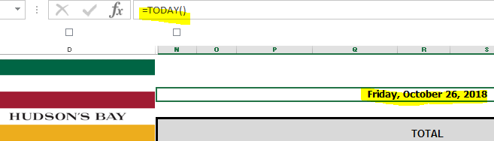

1. Copy entire workflow summary chart (STARTING AT COLUMN N) and paste in Daily Dash tab of the template.
   1. FIND AND REPLACE anything as “#DIV/0!” to “0”
   2. Highlight sheet and ignore errors - 
2. Copy “NOS_Colour_Combined” tab from the raw data file to the For Teams template – the last tab
   1. Copy and Paste as values the entire sheet
   2. Delete top row (WITH FORMULAS)
3. From the raw data file, in Details-Products tab copy from columns “**GMM-Target Pub Date**” and Paste into For Teams template
   1. From the raw data file, in Details-Products tab copy from columns “**Workflow Aging-Lifecycle Comments**” and Paste into For Teams template
4. From the raw data file, in Inactive UPC tab copy entire selection from “**GMM- Current Team**” and Paste into For Teams template
5. Copy the summary chart from WF Summary Chart tab (WIP file) and paste as a picture into word, once it's in word expand the chart so it's larger. Then copy it into the email, once it's ready to be sent. When the teams click on the picture it will expand to the size it was in word.
6. Save down file in Daily Workflow path: I:\Merch Ops\Daily Workflow Report\Bay\MM.DD.YY_Daily Workflow Report_BAY.xlsx
7. Make file read-only – password to modify is ecom678
8. Upload raw Looker files into Google Drive HBC Digital Ops Reports → Daily Bay Looker Files
9. Upload team WF file into Google Drive HBC Digital Ops Reports → Daily Workflow Report → Bay
10. Send out workflow email to distro, can be found [here](https://docs.google.com/spreadsheets/d/1LWmjgjcSbTMoZSJPctl8wgF1rGjccUpTAWcmiYKuwOI/edit#gid=0)